
May 1, 2015

To: Prospective Bidder

Subject: Request for Proposals

Grand Valley State University is accepting proposals for Lawn Care Services for our Facilities Services Grounds Department. Reference attached instructions and specifications.

If you wish to bid on these services, please submit your proposals for bid #215-35 no later than 2:00 PM Friday, May 8, 2015. E-mail your proposal to: RFP-Received@gvsu.edu

Submit your proposal electronically to the above e-mail address by the bid opening date and time. Grand Valley State University is not responsible for e-mail bids affected by spam or not received by the bid opening date & time. No fax, verbal, or telephone proposals will be accepted.

Before submitting proposal, check to be sure that:

- The Proposal/Certification/Contract form is signed and witnessed.
- All addenda received are acknowledged

Note: Electronic submission becomes your authorized signature

Thank you for your participation,

Valerie Rhodes-Sorrelle, C.P.M.
Sr. Strategic Sourcing Specialist

Procurement Services – Zumberge Michigan Hall - Allendale, MI 49401
Phone - 616/331-2283 - Fax 616/331-3287

Grand Valley State University

Bid Instructions & General Information
Lawn Care Services
Bid #215-35

- Grand Valley State University’s sales tax exempt no. 381684280

- Lawn Care Services is for Grand Valley State University’s Facilities Services Grounds Department, for a period of one (1) mowing season, approximately from May 1, 2015 through October 31, 2015.

- The contractor shall furnish all labor, tools, materials, equipment, and supervision necessary for the performance of operations incidental to the initial cleanup, mowing, and trimming necessary to keep the fore mentioned areas in a neat and orderly appearance. The frequency and performance of the work will be in accordance with the specifications set forth.

- Reference attached specifications for complete scope of work

- Record all pricing information on the attached proposal & contract sheet in its entirety or the proposal may be rejected.

- Grand Valley State University endeavors to buy products made in the United States of America whenever an American-made* product is available that meets or exceeds the specifications requested and the price is equal to or lower than a foreign-made product. Vendors are requested to bid American-made products and or services whenever available. Vendors may bid foreign-made products or services when:

  - They are specified
  - They are identified as an alternate by the vendor as long as they are technically acceptable.

  - *More than 50% of the manufactured or assembled in the United States.

- At Grand Valley State University, socially responsible procurement -- which is defined as supporting diversity, socially responsible procurement, and sustainability -- is highly valued. These ideals are fundamental to our academic, research, and athletic excellence. GVSU promotes supplier participation that is reflective of the diverse business community and of the University's desire to procure environmentally friendly products, while remaining focused on socially responsible procurement methodologies.

- GVSU reserves the right to accept or reject any or all Proposals not withdrawn before the opening date and to waive any irregularity or informality in the Proposal process. The University reserves the right to conduct discussions, request additional information and accept revisions of Proposals from any or all bidders. The University reserves the right to negotiate with the bidder whose proposal is deemed most favorable.

- Contact Valerie Rhodes-Sorrelle with any questions concerning this request for proposal at 616/331-2283



General Terms and Conditions (Rev. 11.14.14)
- Not Used
- Not Used
- Not Used
  - Supplemental Conditions

    - The Supplier shall comply with the University’s policy and procedures (http://www.gvsu.edu/purchasing) and any additional instructions issued from time to time by the University.

    - During the period of contract, no change is permitted to any of its conditions and specifications unless the Supplier receives prior written approval from the University.

    - Should the Firm find at any time that existing conditions make modification in contract requirements necessary, it shall promptly report such matter to the University for its consideration and decision.

    - The Firm shall comply with any and all federal, state or local laws, now in effect or hereafter promulgated which apply to the operation herein specified.

    - The Firm’s performance may be evaluated by a designee or an Advisory Committee of the University meeting from time-to-time during the period of contract. It will be the responsibility of the Firm to respond, in writing if so requested, to inquiries, requests for change, and recommendations.

    - The Firm shall provide the University, with telephone numbers and addresses of management personnel and shall arrange for at least one such person to be available during the University’s normal working hours by telephone. The Firm shall also provide sufficient backup in times of staff shortages due to vacations, illnesses, and inclement weather.

    - The Firm shall maintain applicable insurance coverage with appropriate coverage limits. The Firm shall provide the name of the primary insurance carrier and their trade rating which may apply to the operation herein specified.

  - Termination

The University may terminate this agreement for any reason, including but not limited to, changes in the market price of the products and non-appropriation of federal or state funding to university, by delivering not less than thirty days prior written notice to Supplier.

If termination is due to default by Supplier, Supplier shall have ten days from receipt of notice to cure the default. If Supplier fails to cure within the ten-day period, university may terminate this agreement immediately.

The failure of university to exercise its rights of termination for default due to Suppliers failure to perform as required in any one instance shall not constitute a waiver of termination rights in any other instance.

  - General Terms and Conditions

The terms and conditions shall govern any agreement issued as a result of this solicitation.

Additional or attached terms and conditions which are determined to be unacceptable to the University may result in the disqualification of proposals. Examples include, but are not limited to: liability for payment of taxes, subjugation to the laws of another state, and limitations on remedies.

4.3.1 Interpretation, Enforcement and Forum of Laws

For disputes between University and Supplier, this agreement shall be governed by, construed, interpreted, and enforced solely in accordance with the laws of the State of Michigan and the venue of any action shall lie in such state.

4.3.2 Compliance with Law

Supplier warrants and certifies that in the performance of this agreement, it has complied with or will comply with all applicable statutes, rules, regulations and orders of the United States, and any state or political subdivision thereof, including but not limited to, laws and regulations pertaining to labor, wages, hours and other conditions of employment.

4.3.3 Funding Provided by Federal Contracts or Grants

Where federal contracts or grants provide funding to University, it is the responsibility of the Supplier and University to comply with all FAR (Federal Acquisition Regulations) applicable laws and regulations by completing any certifications and disclosures and any other requirements. When federal contract or grant funds are used on purchases under this agreement, which exceed $25,000, certification must be provided in writing that the Supplier is not debarred, suspended, or proposed for debarment by the Federal Government.

4.3.4 Insolvency

In the event of any proceedings in bankruptcy or insolvency by or against Supplier, or in the event of the appointment (with or without it’s consent) of an assignee for the benefit of creditors, or a receiver, University may cancel this agreement without prior notice and without incurring any liability whatsoever to Supplier.

4.3.5 Assignments

Supplier shall not assign this agreement or any of Supplier’s rights or obligations hereunder, without University’s prior written consent. Any purported assignment made without prior written consent shall be void and of no effect.

    - Patent Trademark and Copyright Infringement

The Supplier warrants that the products/services hereby sold, either alone or in combination with other materials, do not infringe upon or violate any patent, copyright, trademark, trade secret, application or any other proprietary right of any third party existing under laws of the United States or any foreign country. The Supplier agrees, at its own expense, to defend any and all actions or suits alleging such infringements and will hold University, its officers, agents, servants, and employees harmless from any and all losses, expenses, claims, (including reasonable attorney’s fees), or judgments arising out of cases of such infringement.

4.3.7 Use of Name, Logos, etc. in Advertising

Supplier agrees not to make reference to this agreement or use University logo or trademarks in any advertising material of any kind without expressed written permission. University agrees not to make reference to this agreement or use the logo of Supplier in any advertising and marketing materials of any kind without the expressed written permission of the Supplier.

4.3.8 Indemnification

Supplier agrees to indemnify and hold University harmless from and against all liability, losses, damages, claims, liens, and expenses (including reasonable legal fees) arising out of or connected with the products purchased, work or services performed, or resulting from damages or injuries incurred by or to University by reason of any defect in manufacture, construction, inspection, delivery, material, workmanship, and/or design of any goods and services furnished hereunder, excepting only such liability as may result solely from the acts of negligence of University or its employees. Supplier, at the request of University, shall undertake to defend any and all suits and to investigate and defend any and all claims whether justified or not, if such claim or suit is commenced against University or its respective officers, agents, servants, and employees.

4.3.9 Insurance

If fabrication, construction, installation, service or other work is specified to be conducted on University premises, Supplier shall maintain in force during the period of such work limits of liability as required by law or as set forth herein, whichever is greater: (a) worker’s compensation, as required by the laws of the State of Michigan; (b) commercial general liability for bodily injury and/or property damage in an amount of not less than $1,000,000 single limit, per occurrence; (c) automobile liability for bodily injury and/or property damage in an amount of not less than $1,000,000 single limit, per occurrence. Supplier shall provide a certificate of insurance naming University as additional insured. Supplier shall furnish to University satisfactory proof of such insurance coverage included with Supplier’s proposal.
4.3.10 Licenses/Permits/Taxes and Tax Exempt Status

Supplier shall be responsible for obtaining all permits, licenses and bonding, to comply with the rules and regulations of any state, federal, municipal or county laws or any city government, bureau or department applicable and assume all liability for all applicable taxes.

University is a 501(c) (3) not-for-profit corporation and is exempt from state sales and use taxes imposed for services rendered and products, equipment or parts supplied.

All prices listed and discounts offered are exclusive of sales and use taxes. Supplier has the duty to collect all taxes in connection with the sale, delivery or use of any items, products or services included herein from University (if for the purpose of resale), at the taxable rate in effect at the time of invoicing. Supplier shall comply with the tax requirements of the State of Michigan. University shall furnish to Supplier a certificate of exemption in form and timeliness acceptable to the applicable taxing authority.

4.3.11 Americans with Disabilities Act

Supplier shall comply with all applicable provisions of the Americans with Disabilities Act and applicable federal regulations under the Act.

4.3.12 Alcohol, Tobacco & Drug Rules and Regulations

Employees of the Supplier and its subcontractors shall comply with all instructions, pertaining to conduct and building regulations of the University. University reserves the right to request the removal or replacement of any undesirable employee at any time.

All buildings at all University locations are tobacco-free. Use of tobacco products is not permitted in any area inside any buildings. Smoking is prohibited within twenty-five (25) feet of any building, within twenty-five feet of any bus stop on University property and within twenty-five feet of the Little Mac Bridge on the Allendale campus. The Supplier is expected to respect this tobacco-free policy and fully comply with it.

The Supplier agrees that in the performance of this agreement, neither the Supplier nor any of its employees shall engage in the unlawful manufacture, distribution, dispensing, possession, or use of a controlled substance, including alcohol, in conducting any activity covered by this agreement. University reserves the right to request a copy of the Drug Free Workplace Policy. The Supplier further agrees to insert a provision similar to this statement in all subcontracts for services required.

4.3.13 Equal Opportunity

The provisions of Section 202 of Executive Order 11246.41 C.F.R. Sec. 60-1.1 C.F.R. Sec. 60-250.4 and 41 C.F.R. Sec. 60-741.4 are incorporated herein by reference and shall be applicable to this agreement unless this agreement is exempted under the rules, regulations, or orders of the U.S. Secretary of Labor.

4.3.14 Non-Discrimination

The parties agree to comply with applicable state and federal rules governing Equal Employment Opportunity and Non-Discrimination.

4.3.15 Sexual Harassment and Bias Incidents

Federal law and the policies of the University prohibit sexual harassment. Supplier is required to exercise control over its employees so as to prohibit acts of sexual harassment. If University in its reasonable judgment determines that any employee of Supplier has committed an act of sexual harassment, Supplier agrees as a term and condition of this agreement to cause such person to be removed from University’s facility and to take such other action as may be reasonably necessary to cause the sexual harassment to cease.

4.3.16 Compliance with Specifications

The Supplier warrants that all goods, services, or work supplied under this agreement shall conform to specifications, drawings, samples, or other descriptions contained or referenced herein and shall be merchantable, of good quality and workmanship and free from defect. The Supplier also warrants that all goods covered by this agreement which are the product of the Supplier or are in accordance with its specifications, will be fit and subject to University inspection before acceptance, and also to later rejection if use reveals defects not apparent upon receipt; and if rejected will be held at Supplier’s risk and expense for storage and other charges after 60 days of storage, goods may be disposed of without cost to University. Neither receipt of goods nor payment therefore shall constitute a waiver of this provision.

4.3.17 Gratuities

University may, by written notice to Supplier, cancel the agreement if it discovers that gratuities, in the form of entertainment, gifts or the like, were offered or given by Supplier to any officer or employee of University with a view toward securing an agreement or securing favorable treatment with respect to the awarding of this agreement.

4.3.18 Covenant Against Contingency Fees

Supplier certifies that it has neither offered nor paid a contingency fee to any individual, agent, or employee of University to secure or influence the decision to award this agreement to Supplier.

4.3.19 Suspension or Debarment

University may, by written notice to the Supplier, immediately terminate the agreement if it is determined that the Supplier has been debarred, suspended or otherwise lawfully prohibited from participating in any public procurement activity, including but not limited to, being disapproved as a subcontractor by any public procurement unit or other governmental body.

4.3.20 Conflict of Interest

In order to avoid even the appearance of any conflict of interest, neither University nor Supplier shall employ any officer or employee of the other party for a period of one year from the date hereof.

4.3.21 Strikes or Lockouts
In the event Supplier should become involved in a labor dispute, strike or lockout, Supplier will be required to make whatever arrangements that may be necessary to insure that the conditions of this agreement are met in their entirety. Should the Supplier be unable to fulfill its obligations under this agreement, University shall have the right to make alternative arrangements to insure the satisfactory performance of the agreement during the time Supplier is unable to perform the required duties. Any costs incurred by University, as a result of such job action, shall be reimbursed by the Supplier.

4.3.22 Force Majeure

Neither party shall be held responsible for any losses resulting if the fulfillment of any terms or provisions of this agreement are delayed or prevented by any cause not within the control of the party whose performance is interfered with, and which by the exercise of reasonable diligence, said party is unable to prevent.

4.3.23 Modification of Terms

No waiver or modification of any of the provisions hereof shall be binding unless mutually agreed upon by University and the Supplier, in writing, with signatures of authorized representatives of all parties authorizing said modification.

4.3.24 Continuation of Performance through Termination

Supplier shall continue to perform, in accordance with the requirements of this agreement, up to the date of termination, as directed in the termination notice.

4.3.25 Open Records

University considers all information, documentation and other materials requested to be submitted in response to this solicitation to be of a non-confidential and/or non-proprietary nature and therefore shall be subject to public disclosure. Supplier is hereby notified that University adheres to all statutes, court decisions and the opinions of the State of Michigan regarding the disclosure of proposal information.

4.3.26 Proprietary/Confidential Information

All information, documentation, and other materials submitted by Respondent in response to this solicitation or under any resulting contract may be subject to public disclosure under the Freedom of Information Act and/or Open Records laws of the University.

4.3.27 Strict Compliance

The parties may at any time insist upon strict compliance with these terms and conditions, notwithstanding any previous custom, practice or course of dealing to the contrary.

4.3.28 Entire Agreement

This agreement together with the Exhibits annexed hereto constitutes the entire agreement between the parties and supersedes all prior agreements whether written or oral between the parties. Documents subject to Freedom of Information Act will only be released after award.

4.3.29 Prevailing Wage Rates
If and where applicable prevailing wage rates apply. Prevailing wage rate information may be included with this document. However, if not, it is the responsibility of the bidder to obtain any and all appropriate prevailing wage rate information.

Lawn Care Services
Specifications
Bid #215-35

Scope of Work

The vendor is to supply equipment, chemicals/materials and personnel to mow, trim, and chemically treat at the Niemeyer, Murray, and Van Steeland Living Centers, the Connections, Calder Art Center, Calder Art Center Residence, and Parking Lot O (see attached map).

All debris which will interfere with cutting operations (such as wire, bottles, rocks, cans, sticks, paper, and litter) shall be cleared from the area prior to beginning operations for the initial mow, and all subsequent mowing’s. Accumulated trash and debris will be accumulated and properly disposed of.

The cutting edges of all mowing equipment used in the performance of the stated work, shall be kept in sharp condition. Rough cutting of grass will not be accepted.

Mowers shall be of a type which cause clippings to be mulched and distributed evenly over the cut area. Any accumulation of grass clippings and other vegetation shall be removed and properly disposed of.

Around all trees, poles, benches, or any areas that grow excessive grass that cannot be cut with a mower, the area will need to be string trimmed around such obstacles.

Care must be taken when mowing and trimming around trees, so the bark is not damaged.

After mowing and trimming, grass clippings and other debris shall be swept or blown off sidewalks and other paved areas.

Grass Cutting and Trimming

Cutting: Grassed areas shall be mowed to a height of not less than two (2) inches above the surface of the soil, and not more than three (3) inches above the soils surface. Grass adjacent to buildings, utilities, trees, or fences, uncut by larger mowers

Trimming: Consistent with each mowing, all grass areas shall be trimmed even with the edges of all curbs, sidewalks, and driveways. Grass, brush, weeds, and other vegetation growing besides walls, guy wires, poles, shrubs, trees, foundations, fenced areas, fire hydrants, or any object within the designated areas shall be cut at a height consistent with the adjoining turf areas.

Property Damage

The contractor shall be responsible for protection of irrigation heads and lines, light poles, sidewalks, and paved surfaces surrounding the building. Any damage and/or necessary repairs to these areas or items, shall be the responsibility of the contractor and repaired immediately.

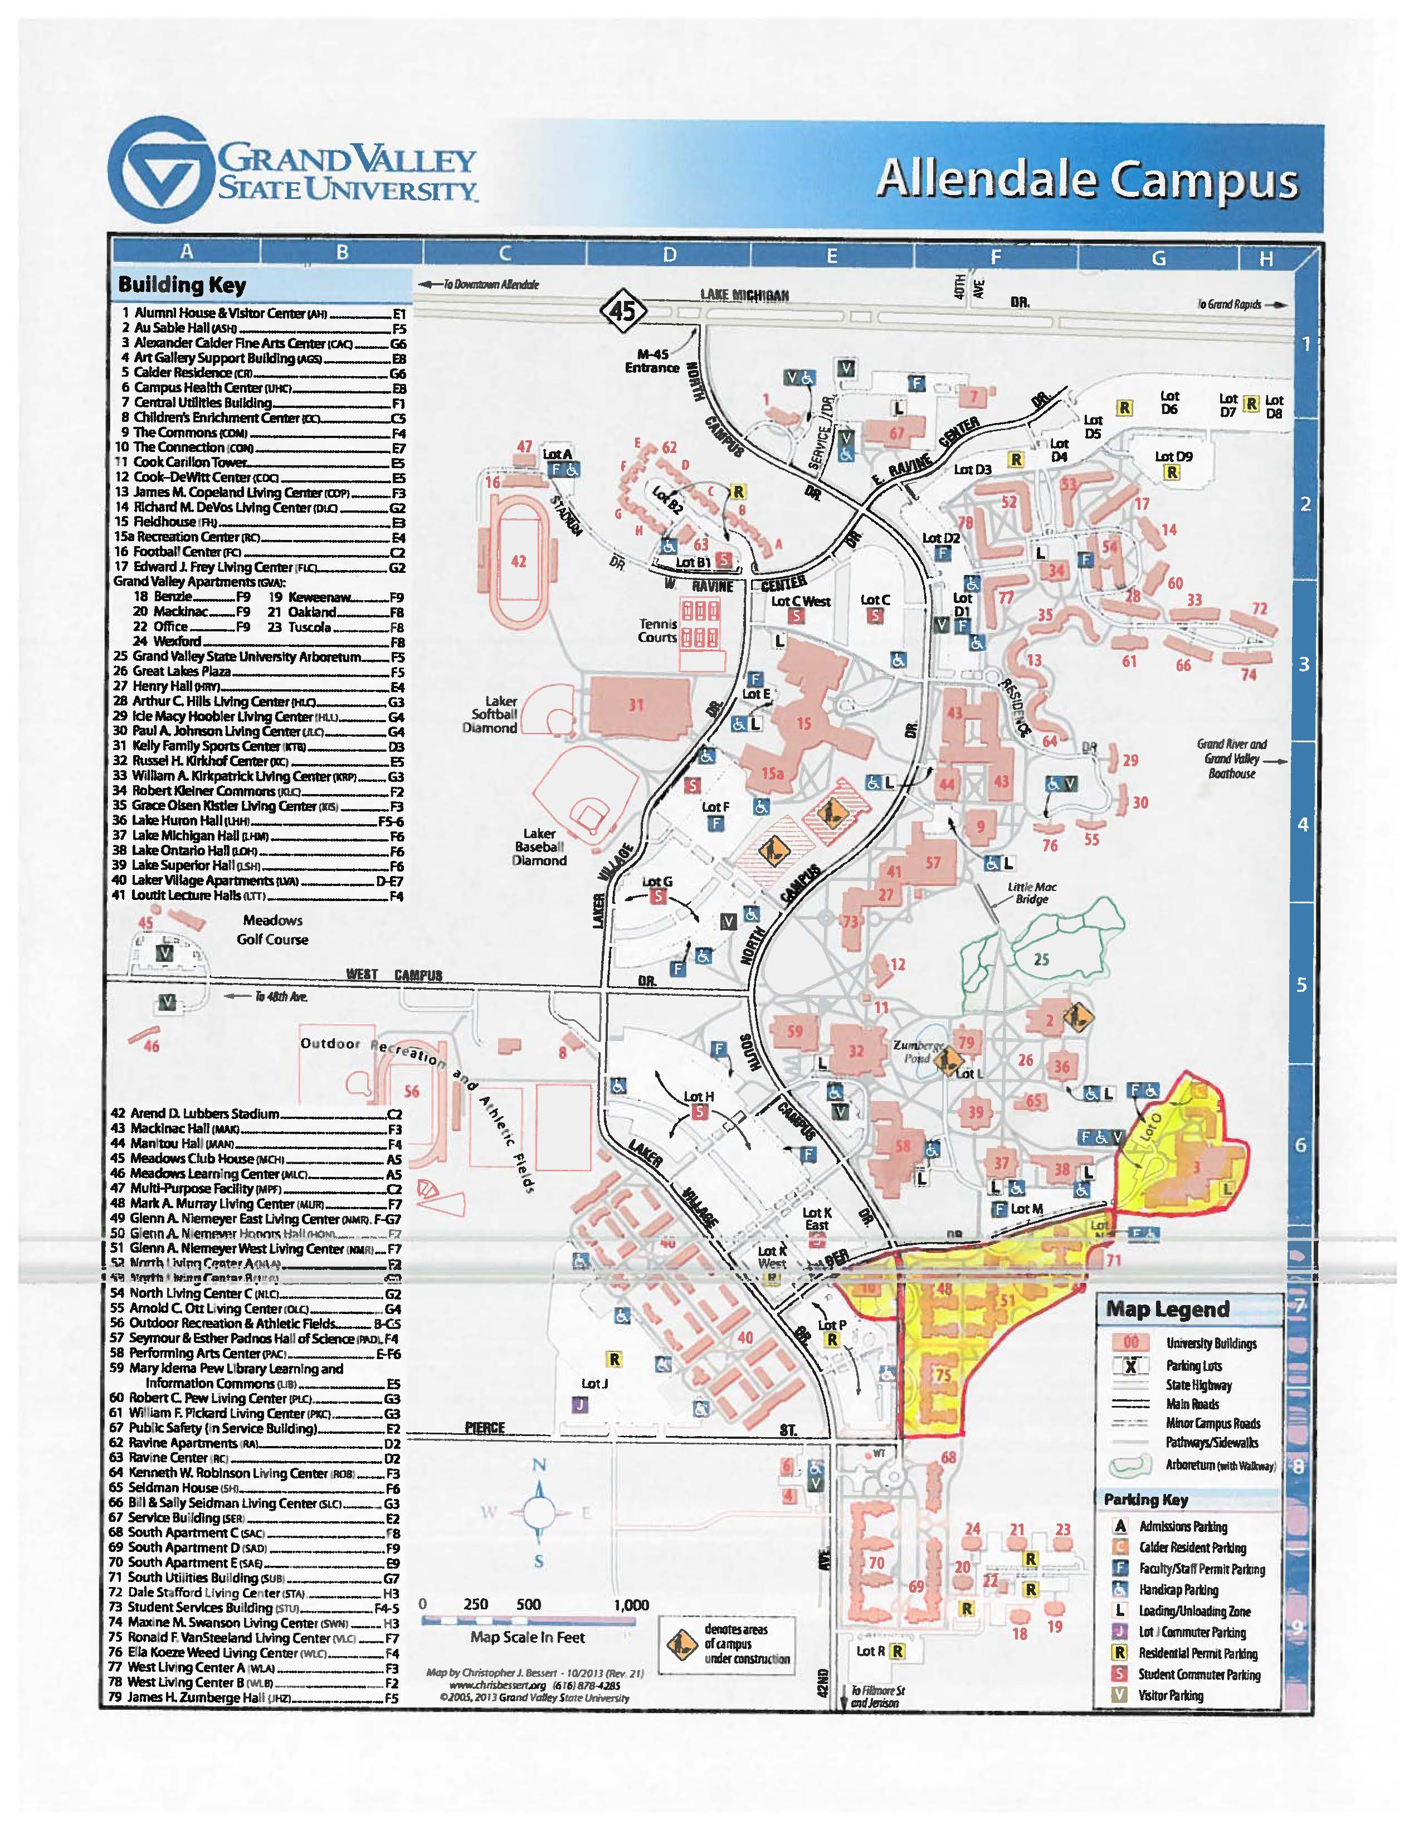

Grand Valley State University
Proposal & Contract

Bid #215-35

Contractor: ________________________________________________________________________________

Date: _________________________________________Bid No.: __________215-35_____________________

Project: Lawn Care Services__________________________________________________________________

Bid opening date and time: Friday, May 8, 2015 - 2:00 PM _________________________________________

Location: 2033 Zumberge Hall _Allendale, MI 495401_____________________________________________

__________________________________________________________________________________________

Attached or included are the following proposed Contract Documents:

- Introduction

- Instructions & Information

- General Terms & Conditions

- Specifications

4. Proposal & Contract

Bidder acknowledges receipt of the following addenda:

Addendum No. ____________ Dated ________________

Addendum No. ____________ Dated ________________

Documents listed herein, including all addenda issues pertaining to same, for the same, for the sum or sums stated below, and agrees that these documents will constitute the contract if accepted by Grand Valley State University.

The undersigned declares the following legal status in submitting this quotation:

[ ] A corporation organized and existing under the laws of the State of ________________

[ ] A partnership

[ ] An individual doing business as (DBA) _______________________________________

The undersigned certifies that company is at least 51% owned, controlled and actively managed by:

African American Asian American Hispanic American
Native American Woman/Women Disabled Person(s)

The undersigned certifies that their company ____ IS or ____IS NOT currently debarred, suspended or proposed for debarment by any federal entity. The undersigned agrees to notify the University of any change in this status, should one occur, until such time as an award has been made under this procurement action.
Proposals submitted will be based on the following scope of work: Cost
(Provide cost for the each item listed below)

- *Weekly mowing and trimming __________

- *Shrub bed pre-emergent (1 time application of Snapshot) __________

- *Weekly shrub bed and sidewalk weed maintenance (spraying) __________

- *Lawn fertilization (2 applications/season w/fertilizer supplied by GVSU) __________

- *Shrub bed plant pruning (1 time per season) __________

- *Sidewalk edging (as requested by GVSU) __________

- *Fall cleanup and perennial plant cut down (optional) __________

____________________________________________________________________________________
Company Name

____________________________________________________________________________________
Address City/State/Zip Code

_________________________ _________________________ ______________________________
Telephone No. Fax No. E-Mail Address

___________________________________________ _______________________________________
Contractor's Signature Name & Title

___________________________________________ _______________________________________
Witness' Signature Name

___________________________________________ _______________________________________
Tax Identification No. Date
ACCEPTANCE: This proposal is accepted by Grand Valley State University

__________________________________________ ________________________________________
Signature of Authorized Agent Name & Title

_________________________ _________________________ ______________________________
Telephone No. Fax No. E-Mail Address

__________________________________________ ________________________________________
Witness' Signature Name

__________ 38 1684280______________________ ________________________________________
GVSU Tax Identification No. Date

Proposals due Friday, May 8, 2015

